Group 2

Module 11.2 Assignment

12/8/23

**Team Members**

Loreto Eclevia

Omar Johnson

Michael Richey

Francisco Sanchez

Have you ever wanted to travel the world? Our team of SQL developers is working with the company Outland Adventures to assist them in creating a database. Outland Adventures is a business created by outdoor enthusiasts to encourage those who have an interest in hiking and camping to explore locations they may not get a chance to explore otherwise.

Blythe Timmerson and Jim Ford and their team of expert guides have made a large number of international trips for their customers to participate in, as well as providing high quality camping and hiking equipment to either rent or buy.

Timmerson and Ford wanted to find out if there was any way they could better optimize their business. Due to this curiosity, they reached out to create a database for their company so they could answer a few questions they had about some of the processes of their business model. One of the things they would like to know is if they are selling enough equipment to justify allowing customers to buy their equipment. They also wanted to know if any of the locations they have trips for seem to be losing popularity. The last thing they were wanting to figure out is if any of their inventory has been sitting on their shelves for over five years.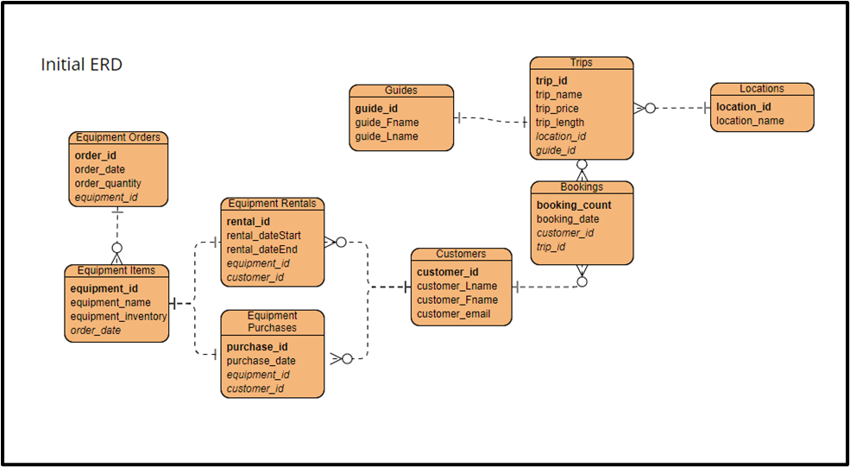

For their first question, we made a report on the total monetary value of all of the orders they had made for equipment. We then compared that to the total monetary value of all the sales they made with the equipment. What we found was 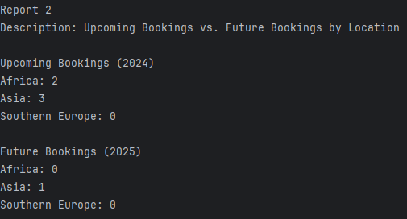that the total of the expenses exceeds the total of sales made.

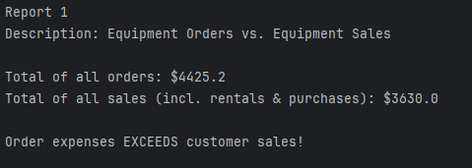The second report we pulled was to show the trends in bookings for the different locations for trips soon and trips in the future. The information given by the report, we can see that Southern Europe is not a popular trip location, as it has had no bookings for its future trips. There is also a trend 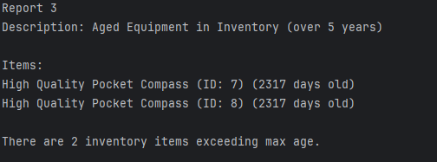for bookings for trips in Asia.

The final report shows the data for any of the equipment that has an age over five years old in the system. This report shows that there are two items that have been in the system for over 5 years, being two high quality pocket compasses.

From this information, Timmerson and Ford can better learn the information they need to better provide great adventures to their customers. That information being that sale prices don’t quite meet enough to make a profit for the company. They can also see that there are some travel destinations that are less popular than others. Finally they can see the items that have been in their inventory for over five years.